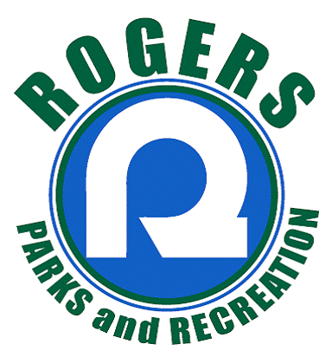
City of Rogers Parks and Recreation Department
22350 South Diamond Lake Road, Rogers, MN 55374
Phone: 763-428-1033 Fax: 763-428-0033
2019 Park Facility Use Agreement
Keys for Triangle & NCP can be picked up at Rogers Activity Center/ice arena one to two days prior to rental date.
Return keys within a couple of days after event.
Lions Central Park
21400 Rouillard Ave.
-shelter picnic area w/ electricity, small ball field, playground, restrooms
[formerly Triangle Park]

North Community Park
13750 Bittersweet St.
-soccer, ftball & ball fields w & w/out lights, gazebo, play-ground, building restrooms

NOTE: Playgrounds CANNOT be reserved – open to public at all times.
(formerly Triangle)
Date Form Submitted: ______________ Park Requesting: Lions Ctrl Park North Community Park (NCP)

Rental Date(s): _______________________ Type of Activity/Purpose: __________________________________

Monday Tuesday Wednesday Thursday Friday Saturday Sunday

Organization/Group: (if applicable) ___________________________________ Estimated Attendance: ________

Time: From _____________ To: ____________ [Include set up/take down time]

Person in Charge: _____________________________________ Email: _________________________________

Address: __________________________________________________ Phone: ___________________________

Reserving: Picnic Shelter Warming House/ Restrooms Other (electricity, lights) ___________________________

Field Reserved: $35.00 Field with Lights $20/field (NCP) Field Type: (ball/football/soccer/volleyball) _______________
Note: Field availability will be verified by Parks & Recreation/request
REFUNDS: Refunds will be issued if notified of cancellation a minimum of one-week prior date of reservation. A $5 Administration Fee will be assessed.
No last-minute refunds, except for extenuating circumstances, will occur. We may be able to find alternate date.
HOLD HARMLESS AGREEMENT
In consideration of the receipt of this permit from the City of Rogers, the Permittee hereby releases the City of Rogers from all injury and any liability of any kind arising from the Permittee’s use and occupancy of City property and agrees to indemnify and HOLD HARMLESS the City of Rogers, its agents, or servants.
In no event shall the City of Rogers be liable for any damage or injury to Permittee or any agent or employee or to any person coming upon the premises in connection with the Permittee’s use and occupancy of the premises.
Permittee acknowledges that it shall reimburse the City of Rogers for any and all damage to property of the City of Rogers, its agents, and/or its servants, as a result of the use and occupancy of the premises (ordinary wear and tear excepted) by Permittee, its agents or servants or by any person coming upon the premises during the Permittee’s use as an invitee or licensee of the Permittee.
Permittee agrees that the rights and obligations under the permit and this agreement shall insure to and be binding on its successors and assigns.
This HOLD HARMLESS agreement MUST be signed by Permittee and received and signed by the City of Rogers before any permit will be issued.

I have fully informed myself of the contents of this agreement before signing it and I do hereby agree to the following stipulations regarding use of the park, equipment, shelters, etc.:
- Keys for park shelter or bathrooms will be picked up & returned upon final clean-up/lock-up to the Rogers Activity Center. (If applicable)
- Park Shelter/Gazebo rental fee for residents: < 50 people $40 50-100 $60 >100 $120
- Park Shelter/Gazebo rental fee for non-residents: < 50 people $50 50-100 $80 >100 $150
For Office Use Only:
_____ Available
_____ Not Available
Alternate site is available: ____________________
CE notified: __________
Maintenance notified of set-up on: __________
Cust notified: ________
Total Cost: __________
Paid Date: ___________
Payment Form: ______
Check #: ____________
Billed Date: _________
Special Events: [Escrow fee based upon actual expenses incurred & all reimbursables]
Permit Fee (Flat Fee) $ 60.00 *NON-REFUNDABLE
Event w/in City Park only (i.e., concerts) - Escrow to be set by Facility Director $250.00 minimum/escrow
Event using City trails, sidewalks, streets, etc. (i.e., charity walks, runs)
Escrow to be set by Facility Director $750.00 minimum/escrow

I, _______________________________________ (Applicant), agree to pay all fees related to park and field usage.
(Printed Name)

_________________________________________________ __________________
(Applicant Signature) (Date)

____________________________________ _____________ __________________
(City of Rogers Permit Approval) (Date)
For Office Use Only:
_____ Available
_____ Not Available
However, alternate site is available: _______________________________
Maintenance notified on: _______________________________
Total Cost: ______________________
Paid Date: ______________________
Payment Form: _________________

Check #: ________________________
Billed Date: _____________________

